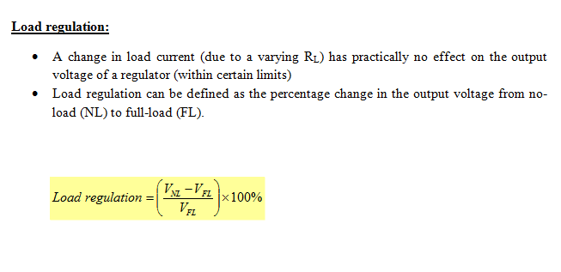 Where:

VNL  = the no-load output voltage

VFL  = the full-load output voltage